Error Occurred:-

Request processing failed;nested exception is org.hibernate.HibernateException: Could not obtain transaction-synchronized session for current thread

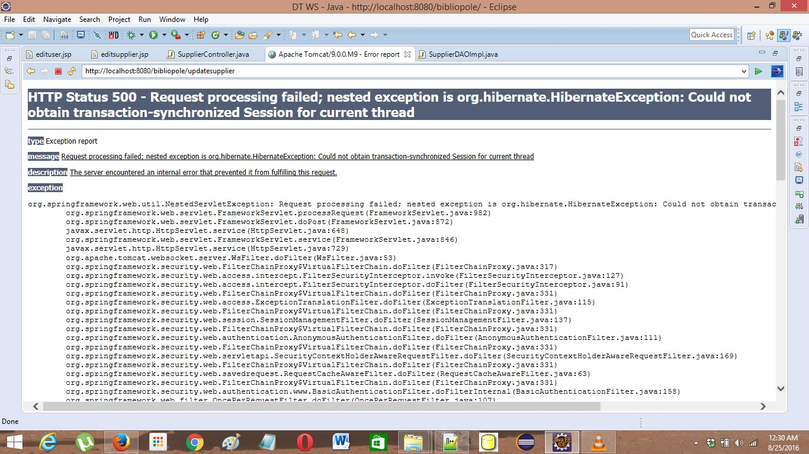

Solution:-

1. Go to the respective DAO implementation.
2. Check all the methods whether they are transactional or not.
3. If not, add @Transactional at that particular method.